Supplier Quality Nonconformance
UX Mockups and Interaction Specification
Document owner | Version | Date | Status
Michael Yaacoub, Sr Solution Engineer | 1.0 | 2026-08-24 | Draft

This template follows the sample UX pack: each SCR screen pairs a visual mockup with a specification panel, and the pack closes with a navigation-flow map.

1. Experience Overview
Two very different contexts share one record. A receiving inspector raises the nonconformance standing at a pallet with a handheld and gloves, often out of coverage; a quality engineer then works the same record at a desk across many open items, and a supplier contact answers it from outside the organisation. Design principles: containment status is never ambiguous and never implied; the impact view says plainly when it is incomplete; supplier-facing screens show only what that supplier may see; and every decision that needs a second person says so before it is attempted.
Persona | Primary goal | Device / viewport | Usage context
Receiving inspector | Record the defect accurately and stop the material moving | Rugged handheld, 5 to 6 inch | Receiving dock, gloved, noisy, intermittent coverage
Supplier quality engineer | Contain the impact, drive supplier corrective action, and close with a costed disposition | Web, 1440 pixels and wider | Quality office, many open nonconformances at once

2. Screen Inventory
Screen ID | Screen name | Mapped feature | User goal | Primary action
SCR-01 | Raise a Nonconformance | FEAT-01 | Record a defect and stop the material | Submit and contain
SCR-02 | Lot Traceability and Impact | FEAT-02 | See everywhere the material already went | Extend containment
SCR-03 | Supplier Corrective Action | FEAT-03 | Get the process fixed, not just answered | Issue the request
SCR-04 | Disposition and Cost of Quality | FEAT-04 | Decide the outcome and record what it cost | Record the disposition

3. Screen Mockups and Specifications

3.1 SCR-01 Raise a Nonconformance
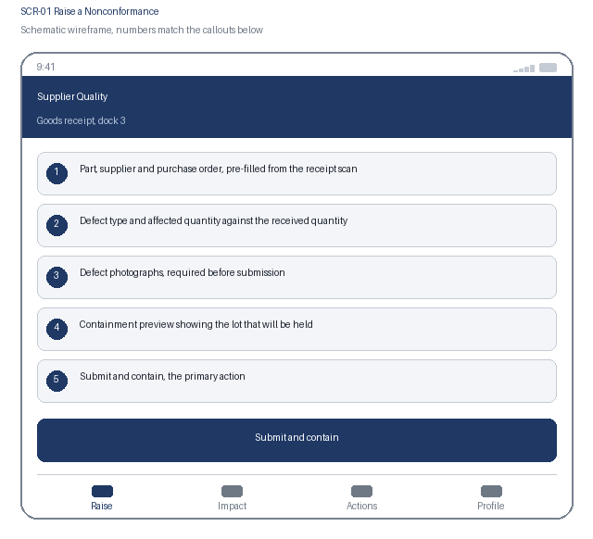  1. Part, supplier and purchase order, pre-filled from the receipt scan  2. Defect type and affected quantity against the received quantity  3. Defect photographs, required before submission  4. Containment preview showing the lot that will be held  5. Submit and contain, the primary action | Specification panel  Purpose: The inspector records the defect where it is found and places an immediate hold on the affected lot.  Primary action: Submit and contain, which issues a nonconformance number and applies the quarantine hold within 60 seconds.  Data: Part number and description, supplier, purchase order, lot, received and affected quantity, defect type and severity, photographs. Source: ERP receipt data through the nonconformance service.  States: Ready to capture, queued offline, submitted, contained, uncontained and alerting  Roles: Inspector raises; quality engineer reads; supplier sees nothing until a request is issued  Requirements: US-101, US-102, NFR-003, NFR-006, NFR-007

3.2 SCR-01 Interaction Details
Element / callout | Behavior | Validation | Accessibility
1. Receipt scan | Pre-fills part, supplier, purchase order and lot from the receipt label | A lot not on an open receipt is rejected with the reason stated | Manual entry always available; pre-filled values are announced as such
2. Affected quantity | Numeric entry bounded by the received quantity | Must be greater than zero and no greater than received; exceeding it blocks with the limit named | Visible label, numeric keyboard hint, assertive error naming the field and the limit
3. Photograph capture | Adds defect photographs; offline captures queue and upload on reconnection | At least one photograph is required before submission | Each thumbnail prompts for a short description used as alternative text
4. Submit and contain | Creates the nonconformance and requests the quarantine hold | If the hold fails, the record is shown as uncontained with the failure explained, never as a generic error | The containment outcome is announced assertively because it is safety and quality critical

3.3 SCR-02 Lot Traceability and Impact
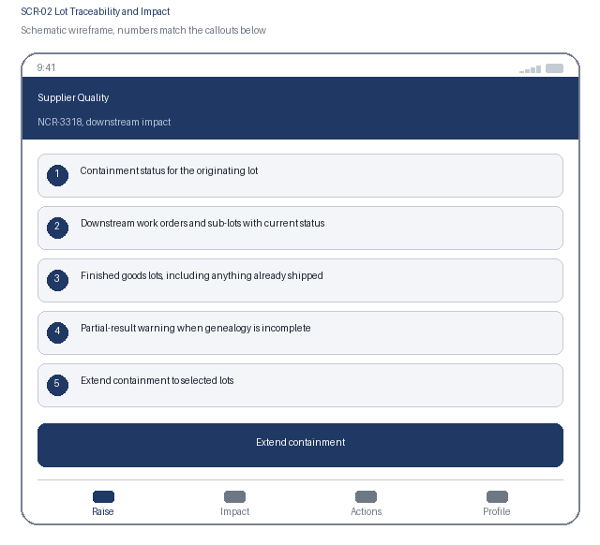  1. Containment status for the originating lot  2. Downstream work orders and sub-lots with current status  3. Finished goods lots, including anything already shipped  4. Partial-result warning when genealogy is incomplete  5. Extend containment to selected lots | Specification panel  Purpose: The engineer sees every lot the affected material reached, so containment covers work in progress and shipped goods rather than only stock on hand.  Primary action: Extend containment, which applies holds to the selected downstream lots and reports each result.  Data: Originating lot and hold state, downstream work orders, sub-lots and finished goods lots with location, status, customer and shipment reference. Source: manufacturing execution genealogy, cached for the life of the nonconformance.  States: Loading, complete genealogy, partial genealogy, containment in progress, partially contained, shipped material identified  Roles: Quality engineer and quality manager; supplier has no access to this view  Requirements: US-201, US-202, NFR-001, NFR-007

3.4 SCR-02 Interaction Details
Element / callout | Behavior | Validation | Accessibility
1. Lot row | Expands to show the consuming work order, date and quantity | None | Disclosure with expanded state announced; hold state stated as text, not colour alone
2. Partial-result warning | Shown whenever the genealogy query did not complete | The view cannot be marked as fully contained while the warning is present | Announced assertively on load, because acting on a partial picture is the risk this prevents
3. Select lots | Multi-select with select-all scoped to the current filter | At least one lot must be selected; already-held lots are shown as such and excluded | Checkbox group with a live count of selected lots announced politely
4. Extend containment | Applies holds in a batch and reports each lot's result individually | A failure on one lot does not roll back the others; failures are listed and retried separately | Results are presented as a list of outcomes rather than a single success or failure message

3.5 SCR-03 Supplier Corrective Action
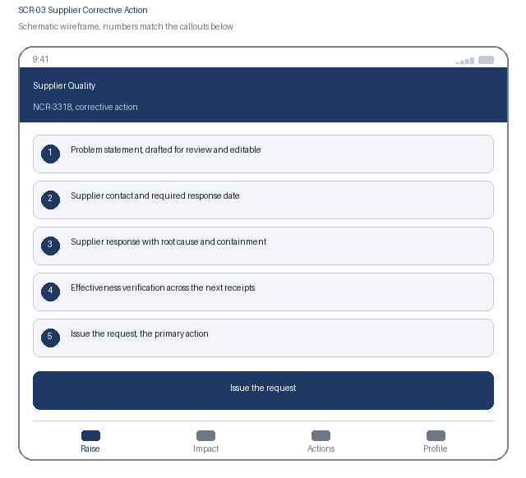  1. Problem statement, drafted for review and editable  2. Supplier contact and required response date  3. Supplier response with root cause and containment  4. Effectiveness verification across the next receipts  5. Issue the request, the primary action | Specification panel  Purpose: The engineer issues a formal request, the supplier answers in the same system, and the request stays open until later receipts prove the fix worked.  Primary action: Issue the request, which notifies the supplier contact and starts the response clock.  Data: Problem statement, supplier contact, required response date, supplier root cause and corrective action, verification receipt count and outcomes. Source: nonconformance service and supplier portal.  States: Draft, issued, awaiting supplier response, overdue, response received, awaiting effectiveness, closed, reopened  Roles: Engineer issues and accepts; supplier contact responds; buyer is notified on overdue  Requirements: US-301, US-302, NFR-004, NFR-006

3.6 SCR-03 Interaction Details
Element / callout | Behavior | Validation | Accessibility
1. Problem statement | Pre-populated with a drafted statement marked as a draft for review | Mandatory, minimum 60 characters; the draft cannot be issued without an explicit accept | The draft is announced as a suggestion; the field is fully editable by keyboard
2. Required response date | Defaults from the defect severity and can be shortened, not extended, without approval | An extension beyond the default requires a reason recorded on the request | Date input with a visible label and the default explained before the field
3. Supplier response panel | Read-only internally until the supplier submits, then opens for acceptance | Acceptance requires a decision and a comment; rejection returns it to the supplier with the reason | The panel states plainly who can act next, so nobody waits on the wrong party
4. Effectiveness verification | Tracks the nominated number of receipts and their inspection outcome | The request cannot close until every verification receipt has passed; a failure reopens it with the new nonconformance linked | Progress is stated as text, for example two of three receipts verified

3.7 SCR-04 Disposition and Cost of Quality
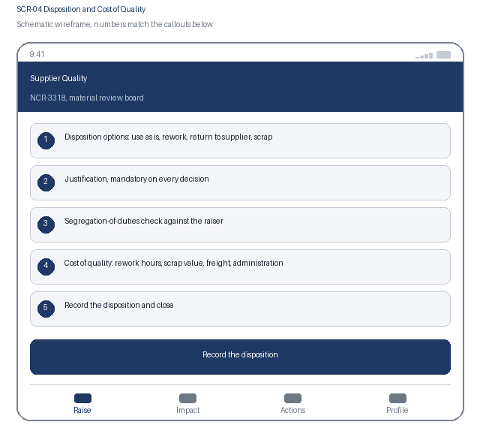  1. Disposition options: use as is, rework, return to supplier, scrap  2. Justification, mandatory on every decision  3. Segregation-of-duties check against the raiser  4. Cost of quality: rework hours, scrap value, freight, administration  5. Record the disposition and close | Specification panel  Purpose: A board member who did not raise the nonconformance decides the outcome for the material and records what the defect cost.  Primary action: Record the disposition and close, which updates inventory and writes the immutable record.  Data: Disposition option, justification, board member identity, segregation-of-duties result, cost lines and total, resulting inventory action. Source: nonconformance service and the ERP.  States: Awaiting disposition, blocked by segregation of duties, dispositioned, inventory update failed and retrying, closed and read-only  Roles: Material review board members with disposition authority; the raiser is excluded  Requirements: US-401, US-402, NFR-004, NFR-006

3.8 SCR-04 Interaction Details
Element / callout | Behavior | Validation | Accessibility
1. Disposition selector | Selecting an option reveals only the cost fields that apply to it | Mandatory; use as is on a safety-critical part requires a second approver | Radio group with a visible legend; revealed fields follow in DOM order and are announced
2. Segregation check | Evaluated server side when the screen opens | If the board member raised the nonconformance, the decision is blocked and alternatives are offered | The block explains why in plain language rather than as a permission error
3. Cost lines | Numeric entry per cost category with a running total | Each line must be zero or greater; the total is calculated, never typed | Totals are announced through a polite live region as lines change
4. Record and close | Writes the immutable record and updates inventory status | Blocked while justification or a required cost line is missing, with each item listed | Confirmation states plainly that the record cannot be edited afterwards

4. Navigation Flow
From | User action / condition | To | Alternate or error path
SCR-01 | Inspector submits and containment succeeds | SCR-02 | Containment fails: the record stays on SCR-01 in an uncontained state and the quality manager is alerted
SCR-02 | Engineer extends containment across downstream lots | SCR-03 | Genealogy incomplete: the partial-result warning persists and full containment cannot be claimed
SCR-03 | Supplier response accepted and effectiveness verified | SCR-04 | Verification receipt fails: the request reopens with the new nonconformance linked
SCR-04 | Board member records a disposition and closes | SCR-01, with the nonconformance closed | Segregation of duties blocks the decision, or the inventory update fails and is retried
Flow: SCR-01 Raise a Nonconformance, submit and contain, to SCR-02 Lot Traceability and Impact, extend containment, to SCR-03 Supplier Corrective Action, effectiveness verified, to SCR-04 Disposition and Cost of Quality, decide and close, and back to SCR-01. A failed containment returns to SCR-01 in an uncontained state, and the bottom tab bar reaches Raise, Impact, Actions and Profile.

5. Responsive Behavior
Viewport | Navigation | Layout | Content priority | Interaction changes
Phone | Bottom tab bar with four primary destinations | Single column, cards stacked in priority order | Part, defect and containment status first; supporting detail below | One-handed reach with capture actions in the lower third; no swipe-only path
Tablet | Adaptive left navigation rail | Nonconformance list beside the selected record's detail | Primary list beside the selected item's detail panel | Touch and pointer both supported; hover reveals nothing essential
Web | Persistent left navigation with breadcrumbs | Register, impact tree and corrective action history in three columns | Dense scanning of many records, with full detail on selection | Full keyboard support with shortcuts for contain and disposition; no hover-only affordance

6. States and Content
State | Trigger | Displayed content | Available actions
Loading | A data request is still in flight after 300 ms | Skeleton content preserving the final layout; the impact tree loads progressively with its depth stated | Cancel and retry remain available
Empty | A filter, search or assignment returns no records | A plain statement that no records match, naming the active filter | Clear the filter, or raise a new nonconformance
Error | A request fails, times out, or is rejected by policy | What failed and whether the material is contained, which is always stated first | Retry, with containment state never assumed on failure
Offline | The device loses network connectivity | A persistent offline banner and a count of records waiting to submit | Capture continues; containment is requested and confirmed only after sync

7. Accessibility Requirements
- WCAG 2.2 AA is the conformance target for every screen, including all interactive states and error messaging.
- Every control is reachable in a logical tab order with a visible focus indicator, a programmatic label, and instructions announced before the input rather than only after an error.
- Errors are announced through an assertive live region, name the field, and describe how to correct the problem.
- Text contrast is at least 4.5 to 1 and non-text indicators at least 3 to 1; the interface remains usable at 200 percent text resize and at 320 CSS pixels wide.
- Motion is limited and honours the reduced-motion preference; no information is conveyed by colour alone.
- Touch targets are at least 44 by 44 CSS pixels with adequate spacing, so the interface stays usable with gloves or one hand.
- {Keyboard order, visible focus, labels, instructions, and error announcement behavior}
- {Contrast, text resize, reduced motion, screen-reader, and touch-target expectations}

8. Review and Approval
Reviewer | Role | Decision | Comments | Date
Design lead | UX design authority | Pending | Interaction model and visual specification
Accessibility specialist | Accessibility | Pending | WCAG 2.2 AA conformance evidence
Product owner | Business product owner | Pending | Screen inventory and flow confirmation

